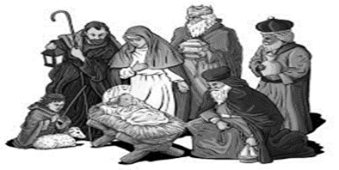

Christmas 2018

Dear Friends,

On Christmas night a single star shone, and its light was cast on the entire world.
This Christmas, as we celebrate the eternal light that shines on us, let us also remember those on whom the light appears dim.

Look around you this Christmas. Notice the light, joy, the kindness and the consideration you experience during this wonderful time “when the world falls in love.”
Perhaps our good feelings stem from the fact that Christmas is the one time we put others before ourselves. We concern ourselves with the things that make others happy. We focus our attention outward and are rewarded with a joyful Christmas.

Our special prayers are with you. May you have an abundance of light, warmth and love that is all around us in this most blessed season. May the Lord fill your heart with joy and shed radiance over the year that lies ahead.

It is with great Joy and excitement that we will celebrate Christmas and invite you and your loved ones to worship with us this year in Holy Ghost Church on Monday, December 24, 2018 at Our Solemn Masses of Christmas at 4pm and Christmas Day Tuesday, December 25th at 10:00am. Also, New Year’s Eve Monday, December 31st 4:00pm and New Year’s Day 2019 at 10:00am.

May the peaceful spirit inspired by the birth of Christ remain with you always!
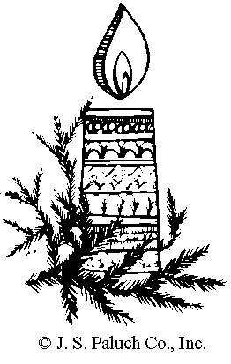

Rev. David J. Kozak, Administrator

